Course content

1. Introduction

2. What is MongoDB?

3. Join our Online Learning Community

4. The Key MongoDB Characteristics (and how they differ from SQL Databases)

5. Understanding the MongoDB Ecosystem

Stop

6. General Setup Instructions & Installing MongoDB on macOS

1

7. Installing MongoDB on Windows

8. Installing the MongoDB Shell

9. Installing mongoimport

10. Time To Get ed!

11. Shell vs Drivers

12. MongoDB + Clients: The Big Picture

13. Course Outline

14. How To Get The Most Out Of The Course

15. Module Introduction

16. Understanding Databases, Collections & Documents

17. The Shell & MongoDB Drivers for Different Languages

18. Creating Databases & Collections

19. Understanding JSON Data

20. Comparing JSON & BSON

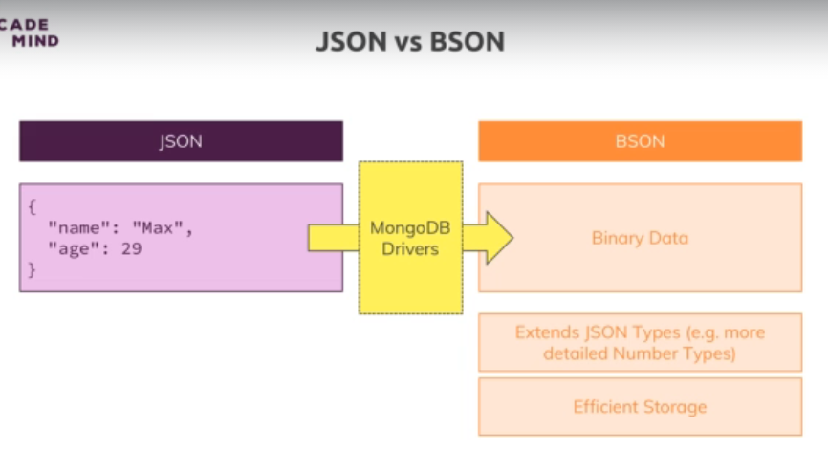

Inserts ObjectId automatically

21. Create, Read, Update, Delete (CRUD) & MongoDB

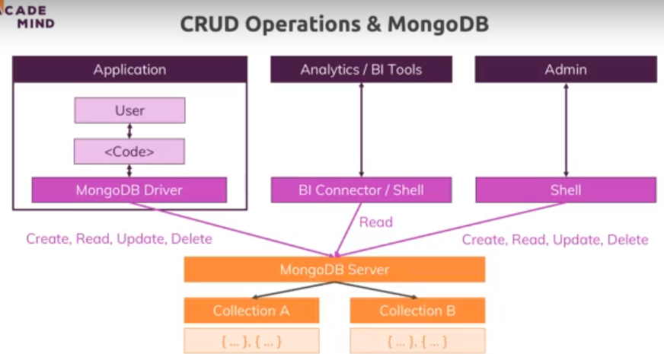

22. Finding, Inserting, Deleting & Updating Elements

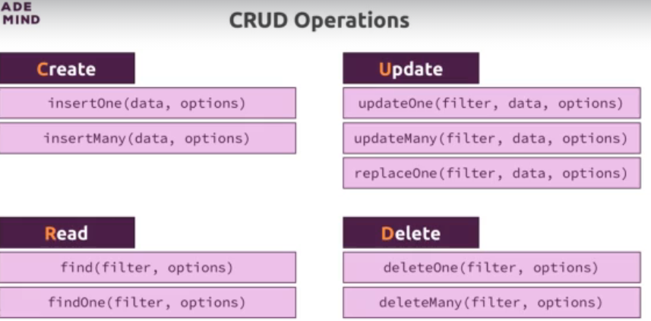

23. Understanding "insertMany()"

insertMany([{},{}])

24. Diving Deeper Into Finding Data

25. "update" vs "updateMany()"

Db.flightData.updateOne({nae:”flight123”},{$set:{isActive:false}})

26. Understanding "find()" & the Cursor Object

Find returns cursor object

Db.flightData.find().toArray()

Db.flightData.find().forEach((flight)=>{

printJson(flight)

})

27. Understanding Projection

28. Embedded Documents & Arrays - The Theory

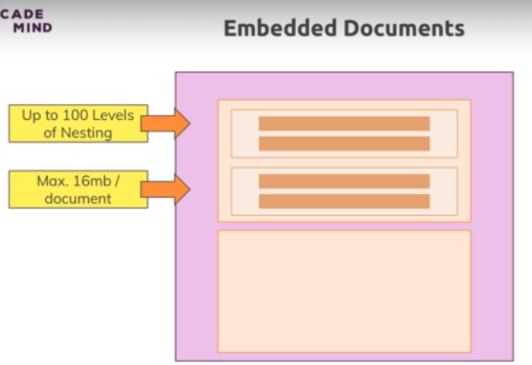

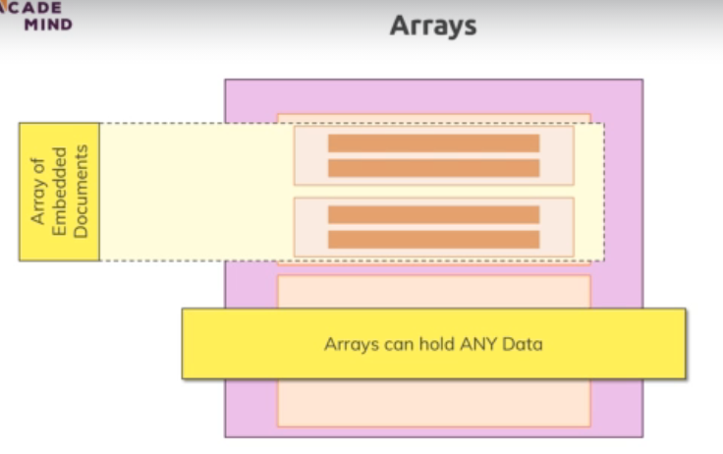

29. Working with Embedded Documents

30. Working with Arrays

31. Accessing Structured Data

Assignment 1: Time to Practice - The Basics & CRUD Operations

32. Wrap Up

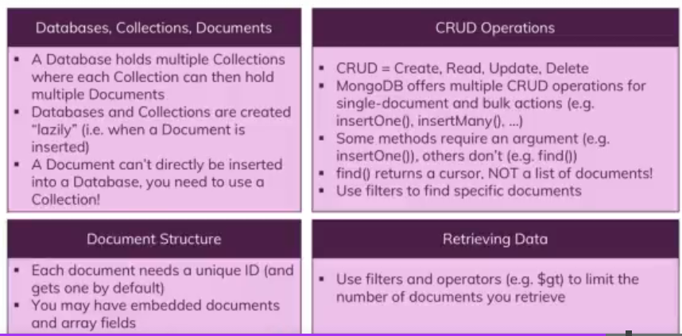

33. Useful Resources & Links

34. Resetting Your Database

35. Module Introduction

36. Why Do We Use Schemas?

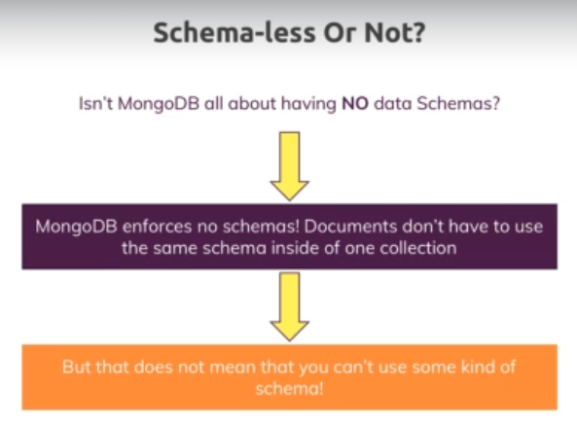

37. Structuring Documents

38. Data Types - An Overview

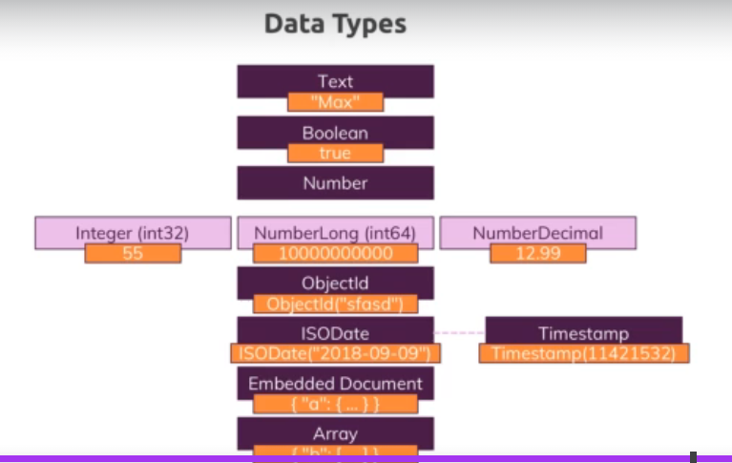

39. Data Types in Action

Db.stats()

40. Data Types & Limits

MongoDB has a couple of hard limits - most importantly, a single document in a collection (including all embedded documents it might have) must be <= **16mb**. Additionally, you may only have **100 levels of embedded documents**.

**Important data type limits are:**

* Normal integers (int32) can hold a maximum value of +-2,147,483,647
* Long integers (int64) can hold a maximum value of +-9,223,372,036,854,775,807
* Text can be as long as you want - the limit is the 16mb restriction for the overall document

It's also important to understand the difference between int32 (NumberInt), int64 (NumberLong) and a normal number as you can enter it in the shell. The same goes for a normal double and NumberDecimal.

**NumberInt** creates a **int32** value => NumberInt(55)

**NumberLong** creates a **int64** value => NumberLong(7489729384792)

If you just use a number (e.g. insertOne({a: 1}), this will get added as a **normal double** into the database. The reason for this is that the shell is based on JS which only knows float/ double values and doesn't differ between integers and floats.

**NumberDecimal** creates a high-precision double value => NumberDecimal("12.99") => This can be helpful for cases where you need (many) exact decimal places for calculations.

When not working with the shell but a MongoDB driver for your app programming language (e.g. PHP, .NET, Node.js, ...), you can use the driver to create these specific numbers.

This will allow you to build a NumberLong value like this:

**const Long = require('mongodb').Long;**

**db.collection('wealth').insert( {**

**value: Long.fromString("121949898291")**

**});**

41. How to Derive your Data Structure - Requirements

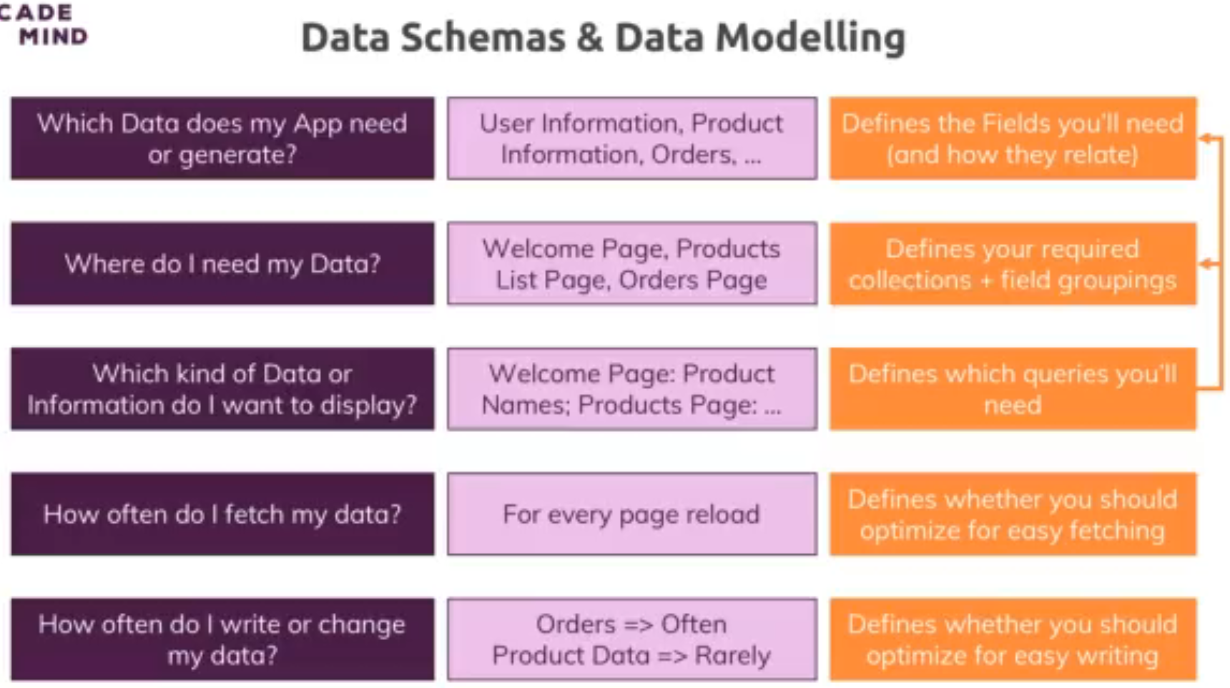

42. Understanding Relations

43. One To One Relations - Embedded

44. One To One - Using References

45. One To Many - Embedded

46. One To Many - Using References

47. Many To Many - Embedded

48. Many To Many - Using References

49. Summarizing Relations

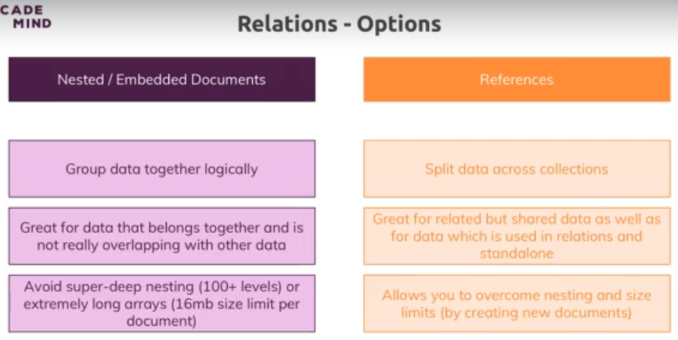

50. Using "lookUp()" for Merging Reference Relations

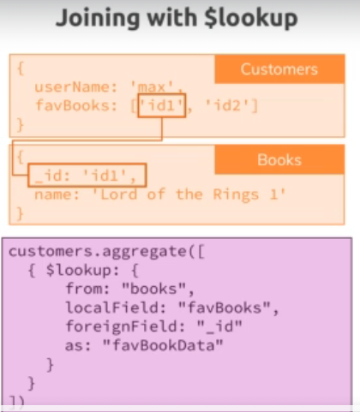

51. Planning the Example Exercise

52. Implementing the Example Exercise

53. Understanding Schema Validation

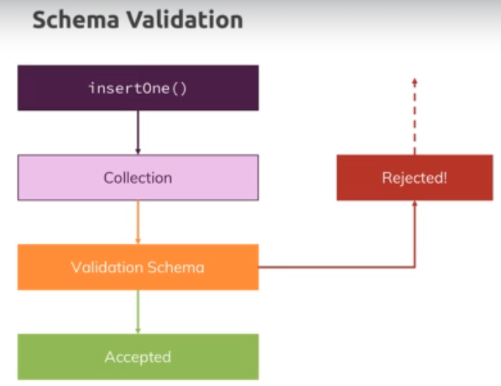

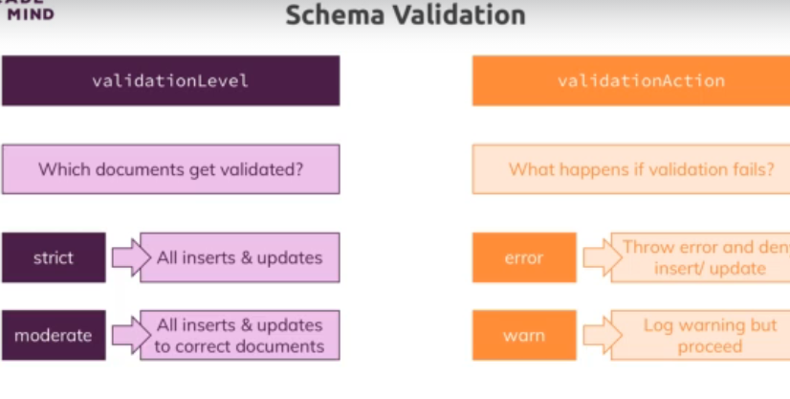

54. Adding Collection Document Validation

**db.createCollection("posts",**

**{validator:{$jsonSchema: {bsonType: "object",**

**required: [**

**'title','text','creator','comments'**

**],**

**properties: {**

**title: {**

**bsonType: "string",**

**description: "must be a string and is required"**

**},**

**text: {**

**bsonType: "string",**

**description: "must be a string and is required"**

**},**

**creator: {**

**bsonType: "objectId",**

**description: "must be an object id and is required"**

**},**

**comments: {**

**bsonType: "array",**

**description: "must be an array and is required",**

**items: {**

**bsonType: "object",**

**required: [**

**"text",**

**"author"**

**],**

**properties: {**

**text: {**

**bsonType: "string",**

**description: "must be a string and is required"**

**},**

**author: {**

**bsonType: "objectId",**

**description: "must be an object id and is required"**

**},**

**}**

**}**

**},**

**}**

**}**

**}**

**});**

55. Changing the Validation Action

**Db.runCommand({**

**collMod:”posts”,**

**validator:{$jsonSchema: {bsonType: "object",**

**required: [**

**'title','text','creator','comments'**

**],**

**properties: {**

**title: {**

**bsonType: "string",**

**description: "must be a string and is required"**

**},**

**text: {**

**bsonType: "string",**

**description: "must be a string and is required"**

**},**

**creator: {**

**bsonType: "objectId",**

**description: "must be an object id and is required"**

**},**

**comments: {**

**bsonType: "array",**

**description: "must be an array and is required",**

**items: {**

**bsonType: "object",**

**required: [**

**"text",**

**"author"**

**],**

**properties: {**

**text: {**

**bsonType: "string",**

**description: "must be a string and is required"**

**},**

**author: {**

**bsonType: "objectId",**

**description: "must be an object id and is required"**

**},**

**}**

**}**

**},**

**}**

**}**

**},**

**validationAction: “warn”**

**})**

56. Wrap Up

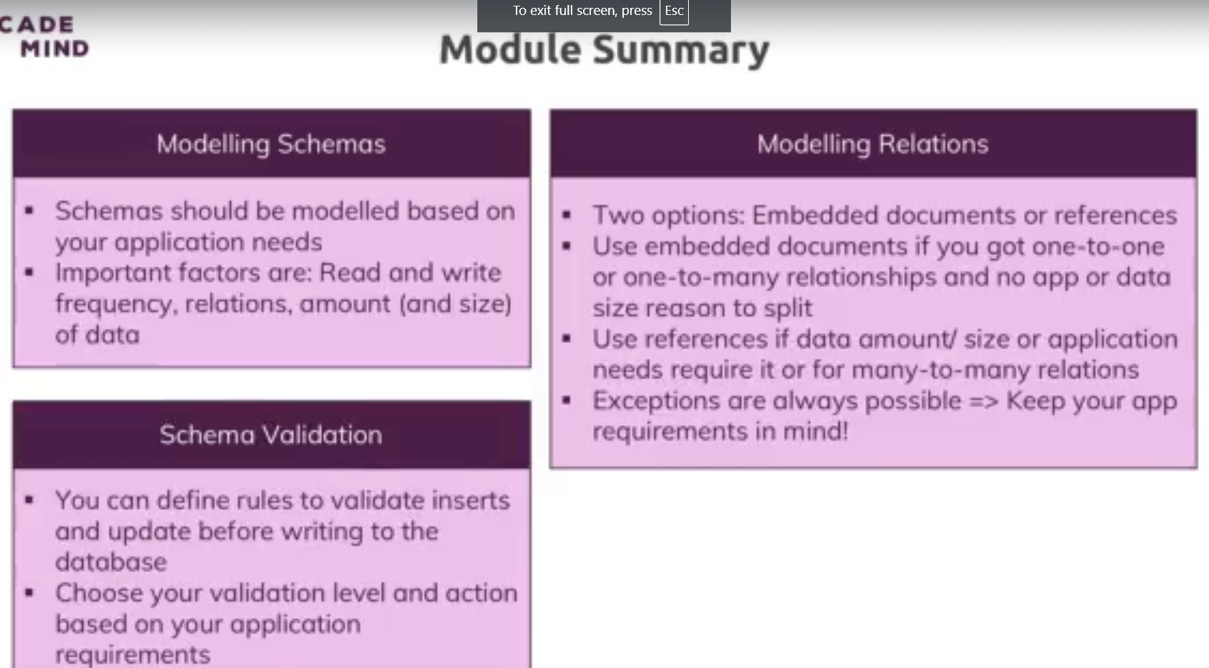

57. Useful Resources & Links

58. Module Introduction

59. Finding Available Options

Mongod --help

60. Setting "dbpath" & "logpath"

61. Exploring the MongoDB Options

62. MongoDB as a Background Service

Mongod –fork –logpath ./logs/log.log

Mongo

Not available in windows

To shut down

Db.shutdownServer()

On windows: stop mongodb

63. Using a Config File

64. Shell Options & Help

65. Useful Resources & Links

66. Module Introduction

67. Exploring the MongoDB Compass

68. Useful Resources & Links

69. Module Introduction

70. Creating Documents - An Overview

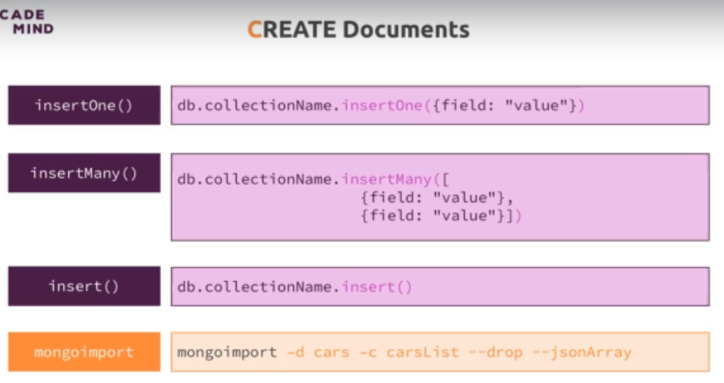

71. Understanding "insert()" Methods

insertOne ad insertMany return object id after insertion,

insert doesnot return.

72. Working with Ordered Inserts

Every insert in insertMany is treated as different insert. If first one succeeds and second fails, first insert will not be rollbacked.

To change default behaviour –



73. Understanding the "writeConcern"

74. The "writeConcern" in Practice

W 🡪 write

J 🡪 journal.. backup file

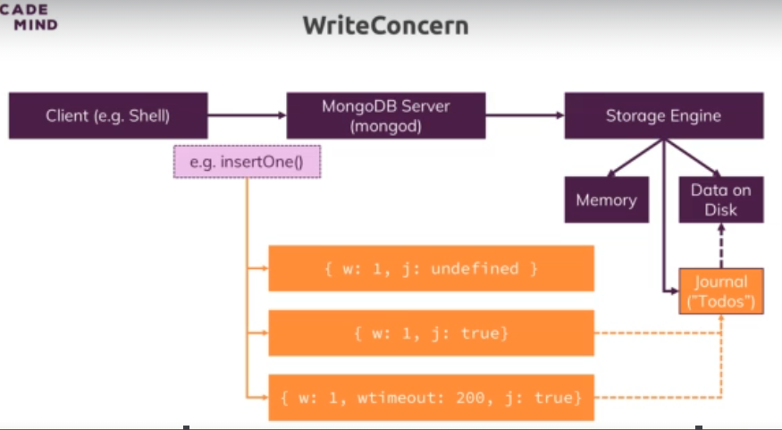

W: 0 🡪 acknowledged false

W: 1 🡪 default

J : false 🡪 default

75. What is Atomicity?

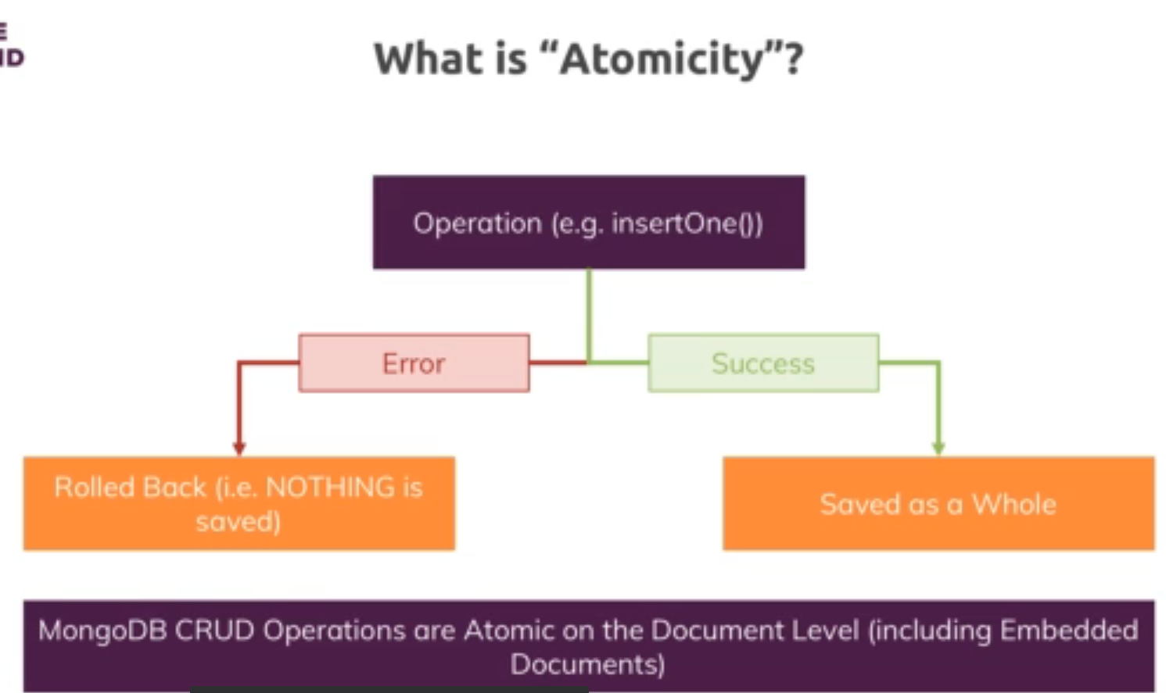

Assignment 2: Time to Practice - Create Operations

76. Importing Data

mongoimport tv-shows.json -d movieData -c movies --jsonArray --drop

77. Wrap Up

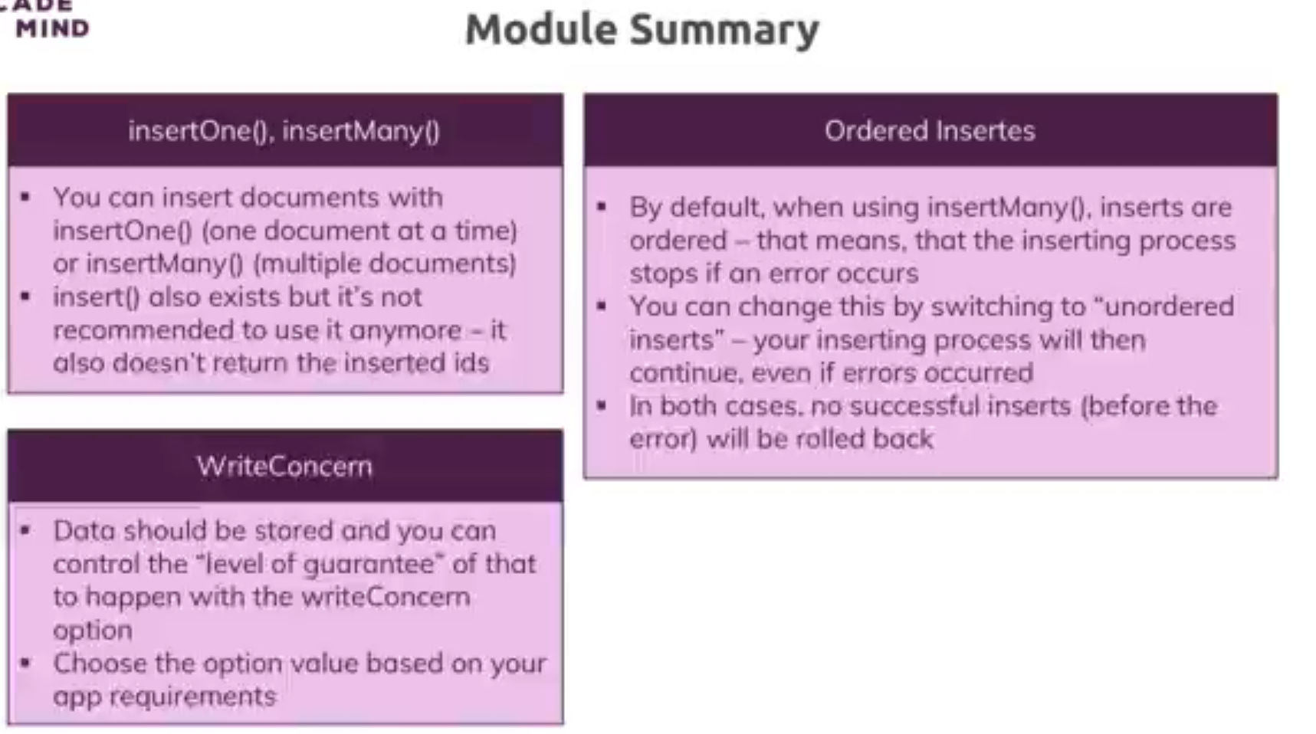

78. Useful Resources & Links

79. Module Introduction

80. Methods, Filters & Operators

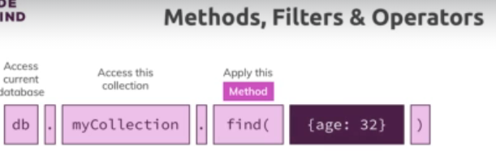

81. Operators - An Overview

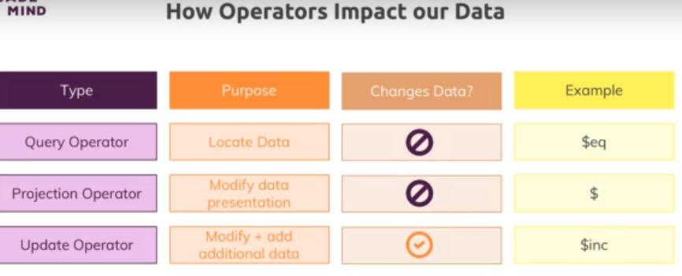

82. Query Selectors & Projection Operators

83. Understanding "findOne()" & "find()"

84. Working with Comparison Operators

85. Querying Embedded Fields & Arrays

86. Understanding "$in" and "$nin"

87. "$or" and "$nor"

88. Understanding the "$and" Operator

89. Using "$not"

90. Diving Into Element Operators





91. Working with "$type"



92. Understanding Evaluation Operators - "$regex"



93. Understanding Evaluation Operators - "$expr"

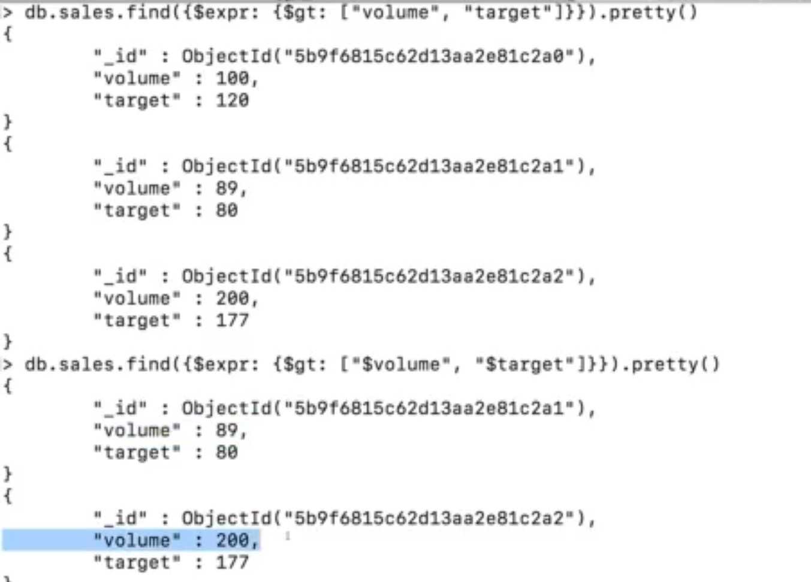



Assignment 3: Time to Practice - Read Operations

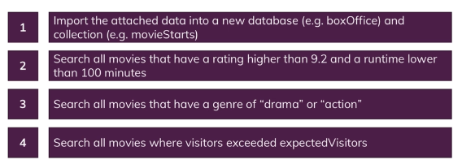

2. db.movies.find({$expr:{$and:[{$gt:["$meta.rating",9.2]},{$gt:["$meta.runtime",50]}]}});

4. db.movies.find({$expr:{$gt:["$visitors","$expectedVisitors"] }})

94. Diving Deeper Into Querying Arrays

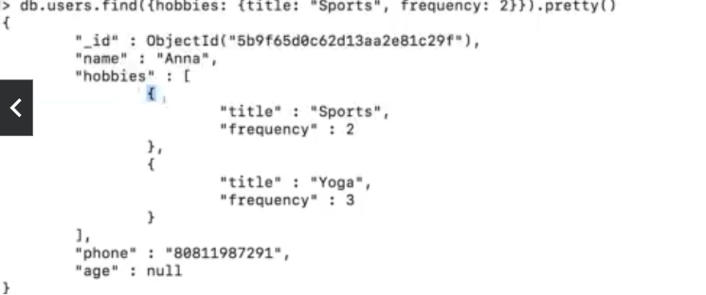

To search in array :



95. Using Array Query Selectors - "$size"

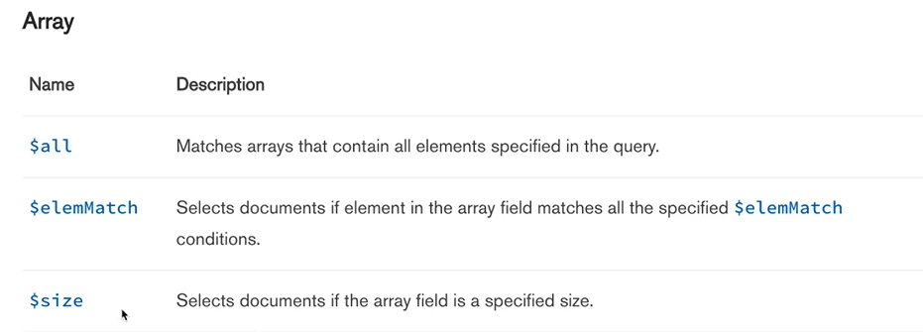



96. Using Array Query Selectors - "$all"



Order does not matter here

97. Using Array Query Selectors - "$elemMatch"

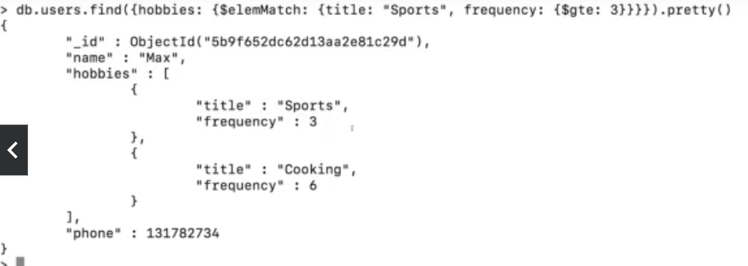

Assignment 4: Time to Practice - Array Query Selectors

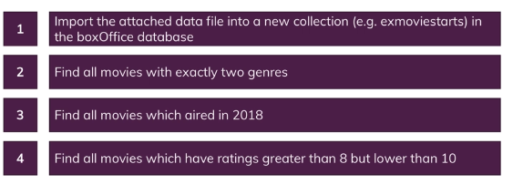

2. db.moviesnew.find({genre:{$size:2}})

3. db.moviesnew.find({"meta.aired":2018})

4. db.moviesnew.find({ratings:{$elemMatch:{$lt:10,$gt:8}}})

98. Understanding Cursors

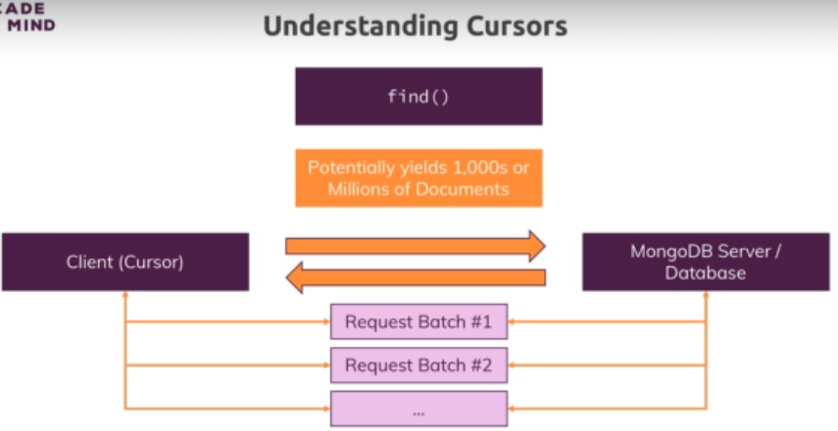

99. Applying Cursors

boxoffice> const cursor = db.movies.find();

boxoffice> cursor.forEach(doc => {printjson(doc.title)});

cursor.next()

cursor.hasNext()

100. Sorting Cursor Results



101. Skipping & Limiting Cursor Results



102. Using Projection to Shape our Results



103. Using Projection in Arrays



S

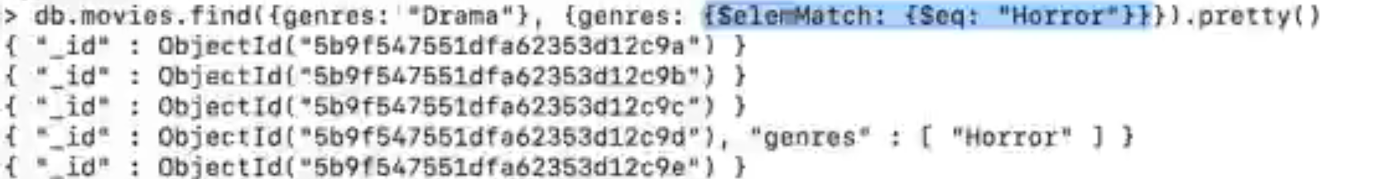

104. Understanding "$slice"

Skip first item and fetch next 2 in gnres



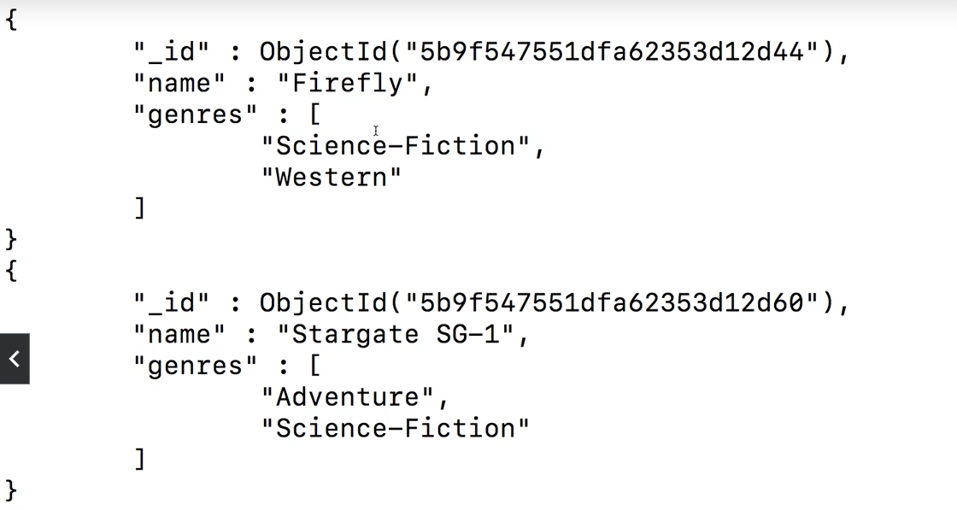



105. Useful Resources & Links

106. Module Introduction

107. Updating Fields with "updateOne()", "updateMany()" and "$set"

108. Updating Multiple Fields with "$set"

109. Incrementing & Decrementing Values



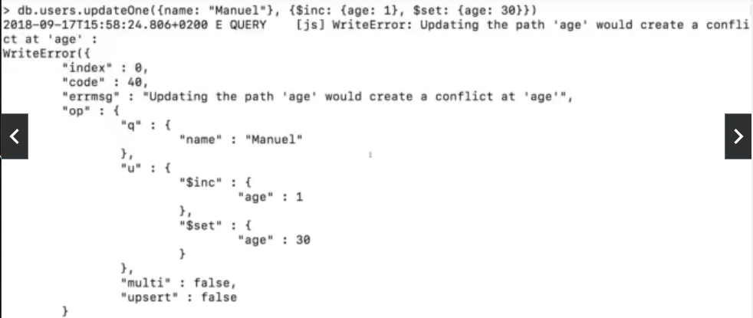

110. Using "$min", "$max" and "$mul"

Chris age is 35





111. Getting Rid of Fields



112. Renaming Fields

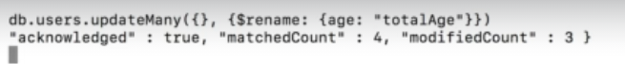

Because one user did not have age field

113. Understanding "upsert()"

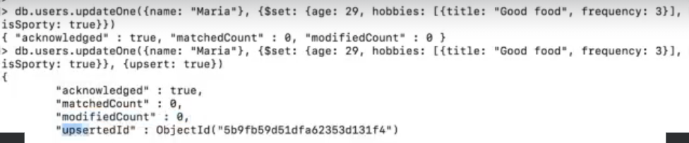

Automatically adds name also in the new document.

Assignment 5: Time to Practice - Update Operations

114. Updating Matched Array Elements



.$. 🡪 first match

115. Updating All Array Elements

.$[]. 🡪 update all matches

**1. .$ Positional Operator**

The .$ positional operator is used to update the **first matching element** in an array that meets the specified query condition.

* **Purpose**: It allows you to update a specific element in an array based on a query filter.
* **Usage**: The .$ operator is used when you want to update a single element in an array that matches a query condition.
* **Example**:

Consider a students collection where each document represents a student and has an array of grades:

javascript

Copy code

{

_id: 1,

name: "John Doe",

grades: [

{ subject: "math", score: 85 },

{ subject: "science", score: 90 }

]

}

To update the score of the science subject to 95:

javascript

Copy code

db.students.updateOne(

{ _id: 1, "grades.subject": "science" },

{ $set: { "grades.$.score": 95 } }

);

**Resulting Document**:

javascript

Copy code

{

_id: 1,

name: "John Doe",

grades: [

{ subject: "math", score: 85 },

{ subject: "science", score: 95 }

]

}

* + **Explanation**: The .$ operator identifies the first element in the grades array that matches the condition grades.subject: "science" and updates its score field to 95.

**2. .$[] Positional All Operator**

The .$[] operator is used to update **all elements** in an array that match a specified condition. It acts as a placeholder for each element in the array.

* **Purpose**: It allows you to apply an update operation to every element in an array, rather than just the first matching element.
* **Usage**: The .$[] operator is used when you need to update multiple elements in an array within a document.
* **Example**:

Consider the same students collection, but now you want to increase the score of every subject by 5:

javascript

Copy code

db.students.updateOne(

{ _id: 1 },

{ $inc: { "grades.$[].score": 5 } }

);

**Resulting Document**:

javascript

Copy code

{

_id: 1,

name: "John Doe",

grades: [

{ subject: "math", score: 90 },

{ subject: "science", score: 95 }

]

}

* + **Explanation**: The .$[] operator iterates over each element in the grades array and applies the $inc operation, increasing each score by 5.

**Summary of Differences**

* **.$ (Positional Operator)**:
  + Updates only the **first** array element that matches the query condition.
  + Used in cases where you know there’s a specific element you want to update.
* **.$[] (Positional All Operator)**:
  + Updates **all** elements in an array.
  + Used when you want to apply an update to every element in an array, regardless of specific conditions.

**Use Cases**

* **Use .$** when you have a condition that identifies a specific element in an array, and you want to update only that element.
* **Use .$[]** when you need to update all elements in an array, typically when applying a uniform change to all array items.

116. Finding & Updating Specific Fields



In MongoDB, the $[<identifier>] is an array filter used in update operations to target specific elements within arrays based on certain conditions. This allows for more complex and fine-grained updates on elements within an array.

**How $[<identifier>] Works**

* **Purpose**: The $[<identifier>] syntax allows you to specify conditions that elements in an array must meet to be updated. You define these conditions in the arrayFilters option of the update operation.
* **Usage**: You use $[<identifier>] in the update statement and then define the corresponding condition in the arrayFilters option. This allows you to target specific elements within an array, even if there are multiple elements that meet different criteria.

**Syntax**

javascript

Copy code

db.collection.updateOne(

{ <query> }, // Filter for the document(s)

{ <update> }, // Update operation with $[<identifier>]

{ arrayFilters: [ { <identifier>: <condition> } ] } // Array filters

);

**Example**

Let's say you have a collection called students, where each student document has an array of grades:

javascript

Copy code

{

_id: 1,

name: "John Doe",

grades: [

{ subject: "math", score: 70 },

{ subject: "science", score: 80 },

{ subject: "history", score: 85 }

]

}

Now, suppose you want to increase the score by 5 for all subjects where the current score is less than 80.

**Using $[<identifier>]:**

javascript

Copy code

db.students.updateOne(

{ _id: 1 },

{ $inc: { "grades.$[el].score": 5 } },

{ arrayFilters: [ { "el.score": { $lt: 80 } } ] }

);

**Resulting Document**:

javascript

Copy code

{

_id: 1,

name: "John Doe",

grades: [

{ subject: "math", score: 75 }, // Score increased by 5

{ subject: "science", score: 80 },

{ subject: "history", score: 85 }

]

}

**Explanation**

* **grades.$[el].score**: Here, el is the identifier used in the array filter. It represents each element in the grades array.
* **arrayFilters: [ { "el.score": { $lt: 80 } } ]**: This defines the condition that the score must be less than 80 for the update to apply to that element. Only the math subject meets this condition, so only its score is incremented.

**Multiple Array Filters**

You can use multiple identifiers with different conditions in the same update operation.

**Example with Multiple Array Filters:**

Suppose you want to update two different conditions: increase the score by 5 for subjects with a score less than 80, and set the subject to "biology" if the score is 85.

javascript

Copy code

db.students.updateOne(

{ _id: 1 },

{

$inc: { "grades.$[lowScore].score": 5 },

$set: { "grades.$[highScore].subject": "biology" }

},

{

arrayFilters: [

{ "lowScore.score": { $lt: 80 } },

{ "highScore.score": 85 }

]

}

);

**Resulting Document**:

javascript

Copy code

{

_id: 1,

name: "John Doe",

grades: [

{ subject: "math", score: 75 }, // Score increased by 5

{ subject: "science", score: 80 },

{ subject: "biology", score: 85 } // Subject changed to biology

]

}

**Summary**

* **$[<identifier>]** is an array filter used in update operations to target specific elements in an array based on conditions.
* **arrayFilters** is the option where you define the conditions that elements must meet to be updated.
* This feature is especially useful when you need to perform complex updates on arrays with multiple conditions.

By using $[<identifier>], you can precisely control which array elements are updated, making your MongoDB updates more powerful and flexible.

117. Adding Elements to Arrays



118. Removing Elements from Arrays





* **Scope of Removal**:
  + **$pull**: Removes **all** elements that match a specific condition.
  + **$pop**: Removes **one** element, either the first or the last, regardless of its value.
* **Use Cases**:
  + **Use $pull**: When you need to remove multiple elements based on a condition.
  + **Use $pop**: When you want to remove just the first or last element from an array.

**Summary**

* **$pull**: Removes all array elements that match a given condition.
* **$pop**: Removes either the first (-1) or last (1) element from an array.

119. Understanding "$addToSet"

**How $addToSet Works**

* **Purpose**: The $addToSet operator adds a value to an array field in a document, but only if that value isn't already present in the array.
* **Usage**: Use $addToSet when you want to add an element to an array while maintaining the uniqueness of elements in that array.

**Syntax**

javascript

Copy code

db.collection.updateOne(

{ <query> }, // Filter to find the document

{ $addToSet: { <arrayField>: <value> } } // The value to add

);

**Example**

Suppose you have a users collection where each user document has an array of tags:

javascript

Copy code

{

_id: 1,

name: "Alice",

tags: ["admin", "editor"]

}

**Adding a Unique Element**

Now, let's say you want to add the tag "contributor" to Alice's tags array:

javascript

Copy code

db.users.updateOne(

{ _id: 1 },

{ $addToSet: { tags: "contributor" } }

);

**Resulting Document**:

javascript

Copy code

{

_id: 1,

name: "Alice",

tags: ["admin", "editor", "contributor"]

}

* **Explanation**: The "contributor" tag was not present in the tags array, so $addToSet added it.

**Attempting to Add a Duplicate Element**

If you try to add the "admin" tag again:

javascript

Copy code

db.users.updateOne(

{ _id: 1 },

{ $addToSet: { tags: "admin" } }

);

**Resulting Document**:

javascript

Copy code

{

_id: 1,

name: "Alice",

tags: ["admin", "editor", "contributor"]

}

* **Explanation**: The "admin" tag was already in the tags array, so $addToSet did not add it again, preserving the uniqueness of the array.

**$addToSet with Multiple Values**

You can also use $each in combination with $addToSet to add multiple values at once, ensuring that each value is added only if it doesn’t already exist in the array.

**Example with $each:**

javascript

Copy code

db.users.updateOne(

{ _id: 1 },

{ $addToSet: { tags: { $each: ["admin", "contributor", "moderator"] } } }

);

**Resulting Document**:

javascript

Copy code

{

_id: 1,

name: "Alice",

tags: ["admin", "editor", "contributor", "moderator"]

}

* **Explanation**: The tags "admin" and "contributor" were already in the array, so only "moderator" was added.

120. Wrap Up

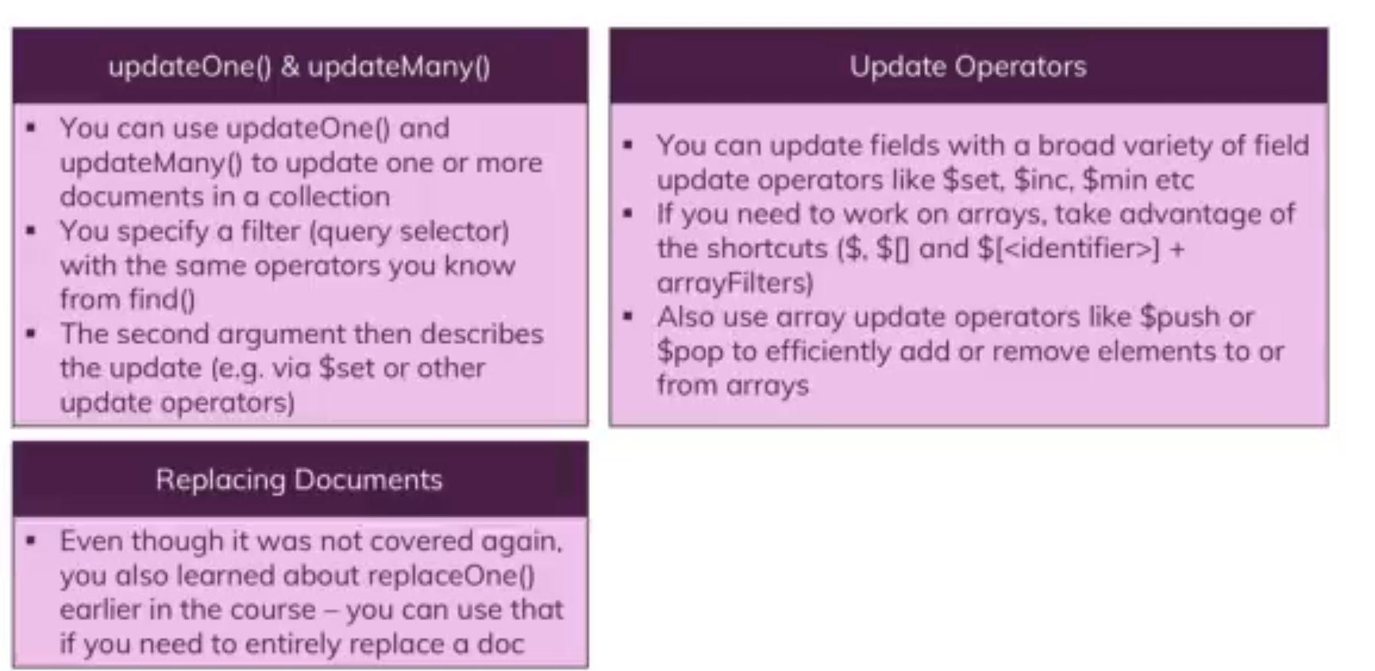

121. Useful Resources & Links

122. Module Introduction

123. Understanding "deleteOne()" & "deleteMany()"

124. Deleting All Entries in a Collection

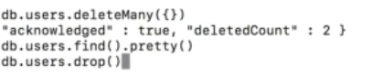

125. Useful Resources & Links

126. Module Introduction

127. What Are Indexes & Why Do We Use Them?

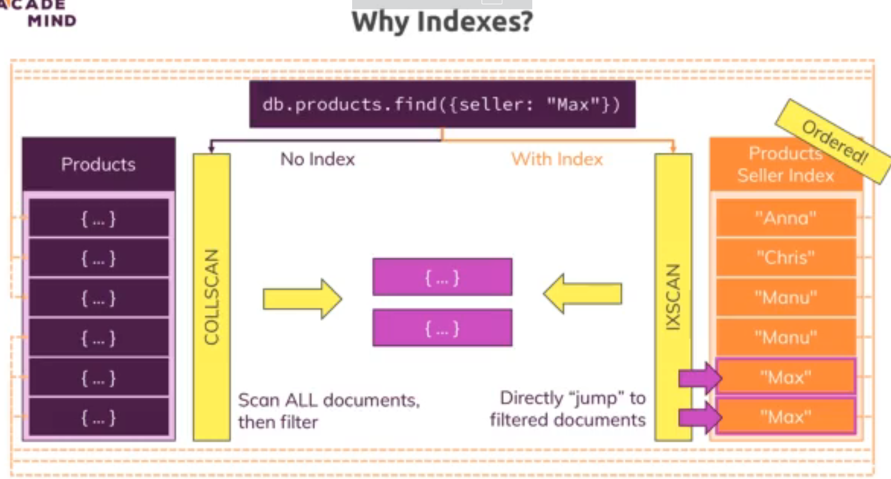

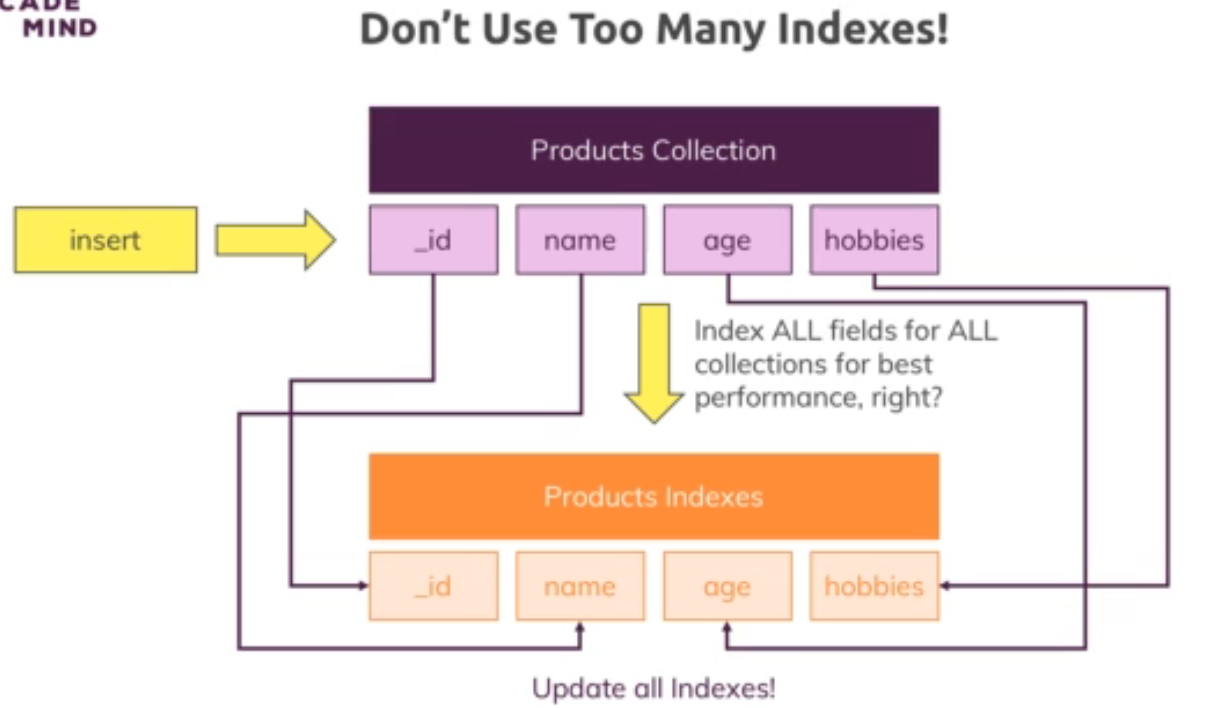

128. Adding a Single Field Index



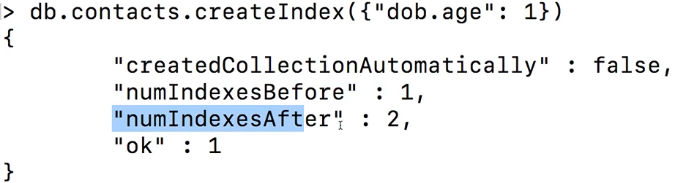

**What does createIndex() do in detail?**

Whilst we can't really see the index, you can think of the index as a simple list of values + pointers to the original document.

Something like this (for the "age" field):

(29, "address in memory/ collection a1")

(30, "address in memory/ collection a2")

(33, "address in memory/ collection a3")

The documents in the collection would be at the "addresses" a1, a2 and a3. The order does not have to match the order in the index (and most likely, it indeed won't).

The important thing is that the index items are **ordered** (ascending or descending - depending on how you created the index). createIndex({age: 1}) creates an index with **ascending sorting**, createIndex({age: -1}) creates one with **descending** **sorting**.

MongoDB is now able to quickly find a fitting document when you filter for its age as it has a sorted list. Sorted lists are way quicker to search because you can skip entire ranges (and don't have to look at every single document).

Additionally, sorting (via sort(...)) will also be sped up because you already have a sorted list. Of course this is only true when sorting for the age.

129. Indexes Behind the Scenes

130. Understanding Index Restrictions

131. Creating Compound Indexes

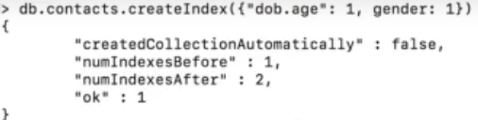

Db engine will do index scan if search on age and gender or only age’Will not work for only gender.

Only left to right will work;

132. Using Indexes for Sorting

133. Understanding the Default Index

Db.contacts.getIndexes()

134. Configuring Indexes

Unique index 🡪

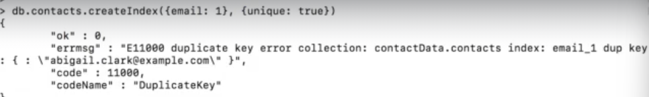

135. Understanding Partial Filters



Partial index 🡪 overall size is less, will only be used if searched using gender as male. Otherwise full index scan will be performed.

136. Applying the Partial Index

Applying index will give an error if more than one email fields have null values. Those are treated as duplicate values. Solution is as follows – combination of unique and partial



137. Understanding the Time-To-Live (TTL) Index

Self destroying data

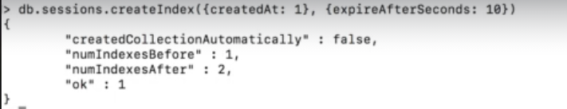

138. Query Diagnosis & Query Planning

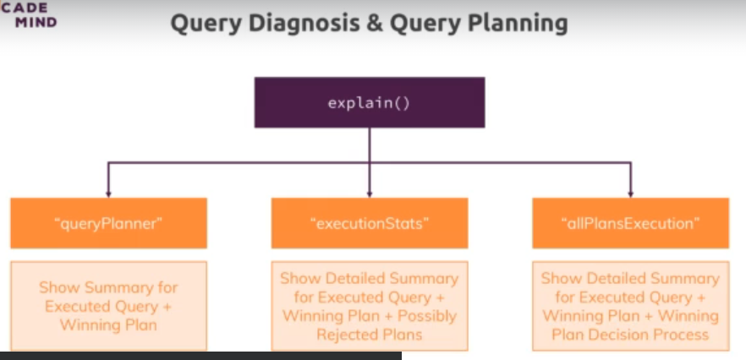

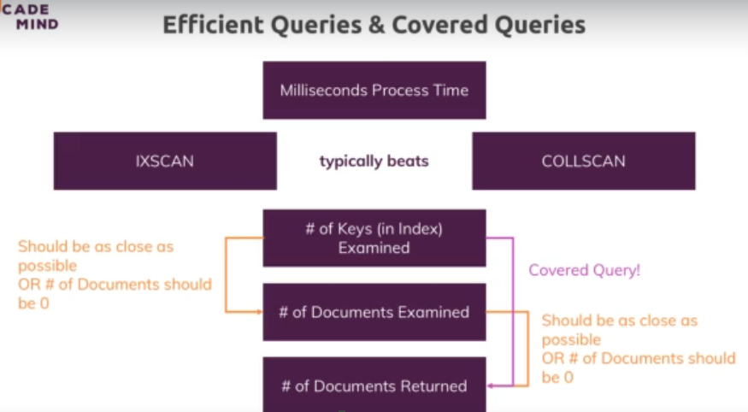

139. Understanding Covered Queries

Case 1) Not a covered query



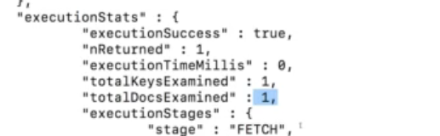

Case 2) Covered query





140. How MongoDB Rejects a Plan

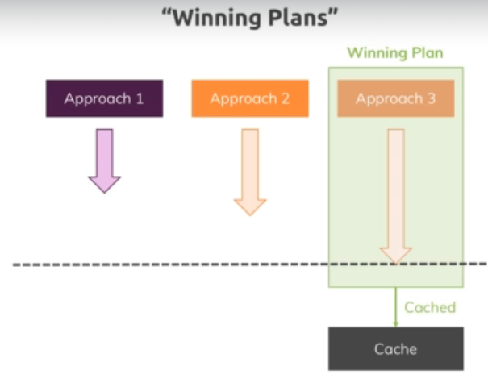

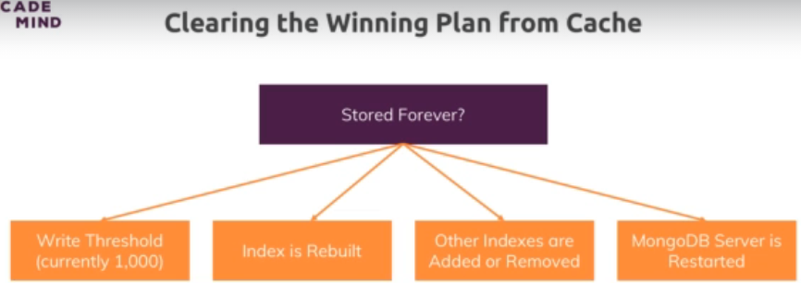



141. Using Multi-Key Indexes

In MongoDB, a **multikey index** is a type of index that allows efficient querying of arrays. When a field in a document is an array, MongoDB can create a multikey index on that field. This enables MongoDB to index each element of the array separately, allowing queries to efficiently search for documents based on the contents of arrays.

**Key Concepts of Multikey Indexes**

1. **Indexing Arrays**:
   * When you create an index on a field that contains an array, MongoDB creates separate index entries for each element of the array.
   * This allows MongoDB to use the index to match individual elements in the array during queries.
2. **Compound Multikey Indexes**:
   * You can create a multikey index on more than one field (a compound index), where one or more of the fields are arrays.
   * MongoDB supports compound indexes with multiple multikey components, but there are some limitations and considerations.

**Example of a Single-Field Multikey Index**

Suppose you have a products collection where each document has an array of tags:

javascript

Copy code

{

_id: 1,

name: "Laptop",

tags: ["electronics", "computing", "portable"]

}

To create a multikey index on the tags field:

javascript

Copy code

db.products.createIndex({ tags: 1 });

**How It Works**

* MongoDB creates index entries for each element in the tags array.
* This allows queries that search for any tag (e.g., "electronics", "computing") to use the index efficiently.

**Example Queries**

* Find all products with the tag "computing":

javascript

Copy code

db.products.find({ tags: "computing" });

This query uses the multikey index on tags to efficiently find all documents where "computing" is an element in the tags array.

**Compound Multikey Indexes**

Consider a scenario where you have a posts collection with the following structure:

javascript

Copy code

{

_id: 1,

title: "Introduction to MongoDB",

tags: ["database", "nosql"],

authors: ["John Doe", "Jane Doe"]

}

You can create a compound index on both the tags and authors fields:

javascript

Copy code

db.posts.createIndex({ tags: 1, authors: 1 });

**How Compound Multikey Indexes Work**

* MongoDB creates index entries for each combination of elements in the tags and authors arrays.
* This allows for efficient querying based on both fields.

**Example Query Using a Compound Multikey Index**

* Find all posts with the tag "nosql" and an author "Jane Doe":

javascript

Copy code

db.posts.find({ tags: "nosql", authors: "Jane Doe" });

This query uses the compound multikey index to efficiently search for documents that match both conditions.

**Limitations of Multikey Indexes**

1. **One Array Per Index**:
   * In a compound index, if multiple fields are arrays, MongoDB will only index documents where one array field is used. This means that the index will not cover queries that involve multiple array fields unless those fields meet specific conditions.
2. **Cannot Directly Index Nested Arrays**:
   * MongoDB does not support multikey indexes on fields that are arrays of arrays.
3. **Index Size**:
   * Multikey indexes can become large, especially if the arrays have many elements. This can impact the performance of both indexing operations and queries.
4. **Sort and Query Together**:
   * When using a multikey index to sort and filter simultaneously, MongoDB may not use the index efficiently if the sort order and the query conditions don't align well with the index structure.

**Summary**

142. Understanding Text Indexes

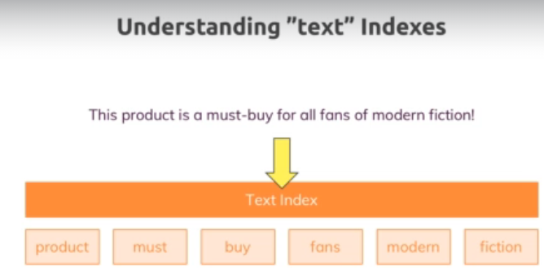

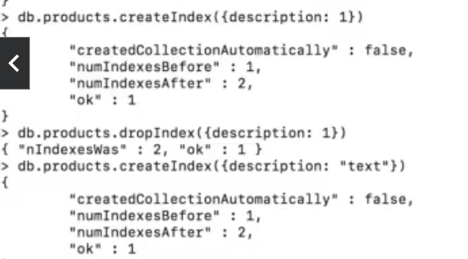

143. Text Indexes & Sorting

To search for exact text , “\”red book\””

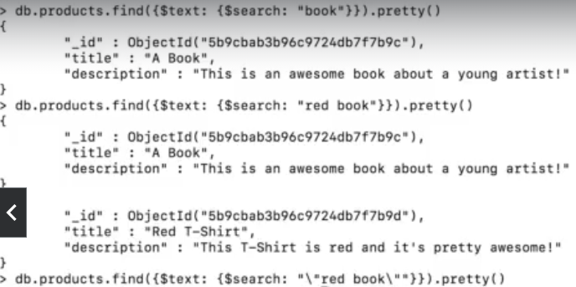

In MongoDB, the $meta operator is used to access metadata about documents during query operations, particularly with text search or when retrieving metadata associated with an index, such as text scores or other ranking information. This operator is typically used within the projection part of a query to include metadata fields in the result set.

**Common Use Cases of $meta**

1. **Text Search Relevance Score**:
   * When performing a text search in MongoDB, the $meta operator can be used to include the text search relevance score (textScore) in the query results.
2. **Sorting by Metadata**:
   * You can use $meta to sort query results based on metadata, such as sorting by text search relevance scores.

**Example: Using $meta with Text Search**

Suppose you have a collection of articles, and you've created a text index on the content field:

javascript

Copy code

db.articles.createIndex({ content: "text" });

Now, let's say you want to search for the term "mongodb" in the content field and include the relevance score in the results.

**Query Example**

javascript

Copy code

db.articles.find(

{ $text: { $search: "mongodb" } },

{ score: { $meta: "textScore" } }

);

* **Explanation**:
  + The { $text: { $search: "mongodb" } } performs a text search for the term "mongodb".
  + The { score: { $meta: "textScore" } } includes the relevance score (computed by MongoDB based on the text search) in the results under the score field.

**Example Result**

javascript

Copy code

{

_id: 1,

title: "Introduction to MongoDB",

content: "MongoDB is a NoSQL database...",

score: 1.5

},

{

_id: 2,

title: "Advanced MongoDB Techniques",

content: "This article discusses advanced topics in MongoDB...",

score: 1.2

}

* **Explanation**: Each document in the result includes a score field that indicates how relevant the document is to the search query.

**Sorting by Text Search Score**

You can also sort the query results by their relevance score using $meta:

javascript

Copy code

db.articles.find(

{ $text: { $search: "mongodb" } },

{ score: { $meta: "textScore" } }

).sort({ score: { $meta: "textScore" } });

* **Explanation**: The results will be sorted in descending order of their text search relevance scores.

**Other Use Cases of $meta**

* **Index Information**: The $meta operator can also be used in other contexts, such as retrieving index information for geospatial queries or getting information about custom indexes that store metadata.

**Summary**

* **$meta Operator**: Used to include metadata in query results or to sort based on metadata.
* **Text Search Relevance Score**: Commonly used with text search to include and sort by the relevance score (textScore).
* **Syntax**: The $meta operator is typically used in the projection or sort part of a query.
* **Use Cases**: Text search scoring, sorting by relevance, and accessing index-related metadata.

The $meta operator is especially useful for applications where you need to rank or filter results based on custom metadata, like search relevance scores.

144. Creating Combined Text Indexes

145. Using Text Indexes to Exclude Words

146. Setting the Default Language & Using Weights

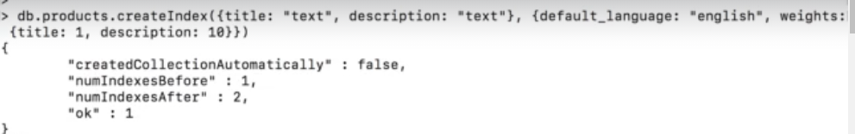

147. Building Indexes

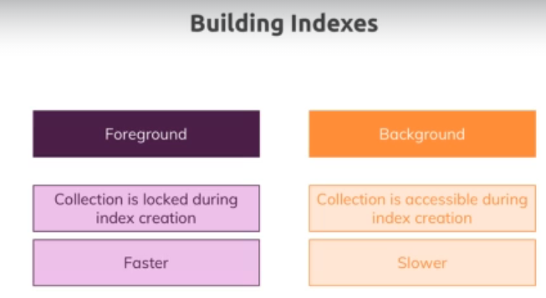

148. Wrap Up

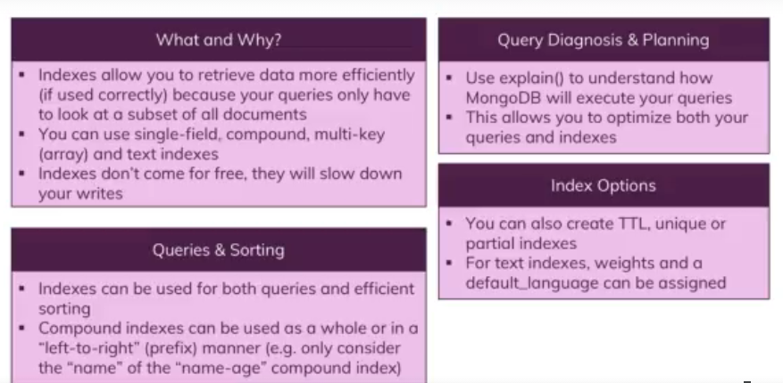

149. Useful Resources & Links

150. Module Introduction

151. Adding GeoJSON Data

152. Running Geo Queries

153. Adding a Geospatial Index to Track the Distance

154. Adding Additional Locations

155. Finding Places Inside a Certain Area

156. Finding Out If a User Is Inside a Specific Area

157. Finding Places Within a Certain Radius

Assignment 6: Time to Practice - Geospatial Data

158. Wrap Up

159. Useful Resources & Links

160. Module Introduction

161. What is the Aggregation Framework?

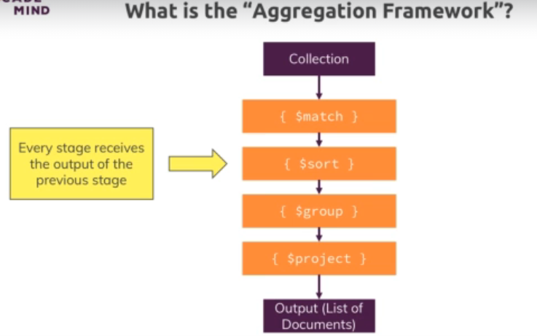

162. Getting ed with the Aggregation Pipeline

163. Using the Aggregation Framework

164. Understanding the Group Stage

165. Diving Deeper Into the Group Stage

Assignment 7: Time to Practice - The Aggregation Framework

166. Working with $project

167. Turning the Location Into a geoJSON Object

168. Transforming the Birthdate

169. Using Shortcuts for Transformations

170. Understanding the $isoWeekYear Operator

171. $group vs $project

172. Pushing Elements Into Newly Created Arrays

173. Understanding the $unwind Stage

174. Eliminating Duplicate Values

175. Using Projection with Arrays

176. Getting the Length of an Array

177. Using the $filter Operator

178. Applying Multiple Operations to our Array

179. Understanding $bucket

180. Diving Into Additional Stages

181. How MongoDB Optimizes Your Aggregation Pipelines

182. Writing Pipeline Results Into a New Collection

183. Working with the $geoNear Stage

184. Wrap Up

185. Useful Resources & Links

186. Module Introduction

187. Number Types - An Overview

188. MongoDB Shell & Data Types

189. Understanding Programming Language Defaults

190. Working with int32

191. Working with int64

192. Doing Maths with Floats int32s & int64s

193. What's Wrong with Normal Doubles?

194. Working with Decimal 128bit

195. Wrap Up

196. Useful Resources & Links

197. Module Introduction

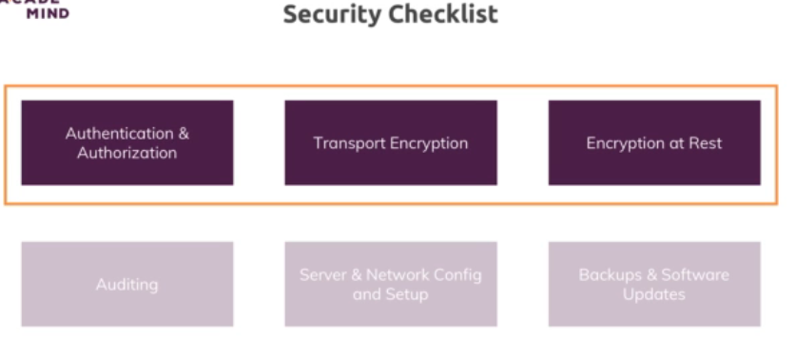

198. Understanding Role Based Access Control

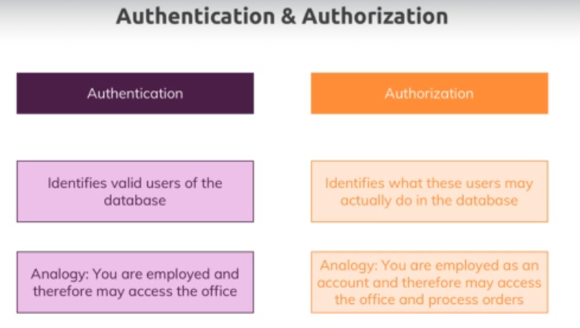

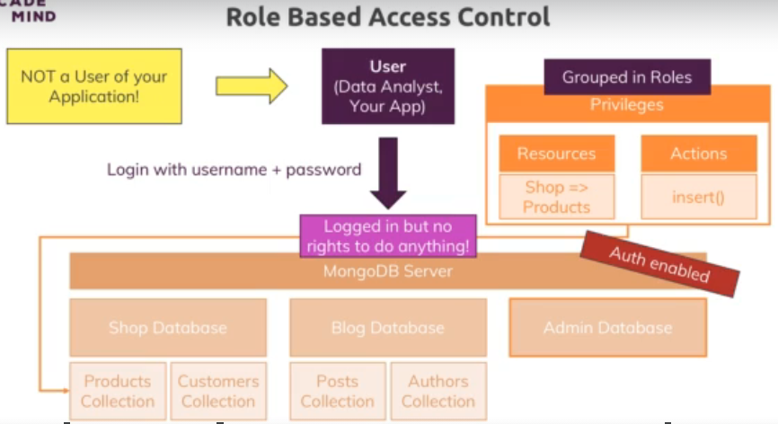

199. Roles - Examples

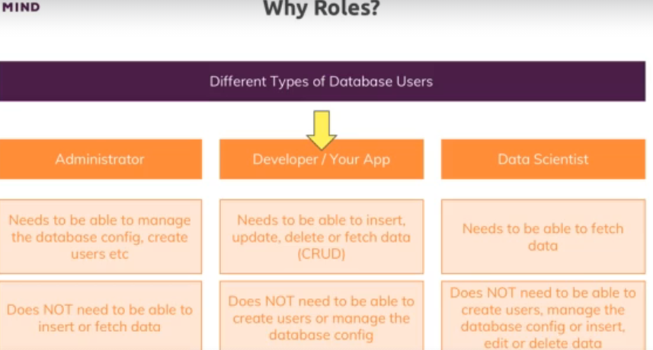

200. Creating a User

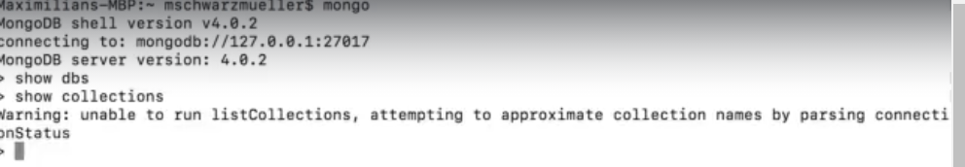

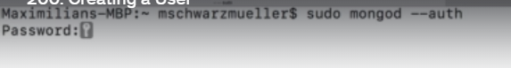





201. Built-In Roles - An Overview

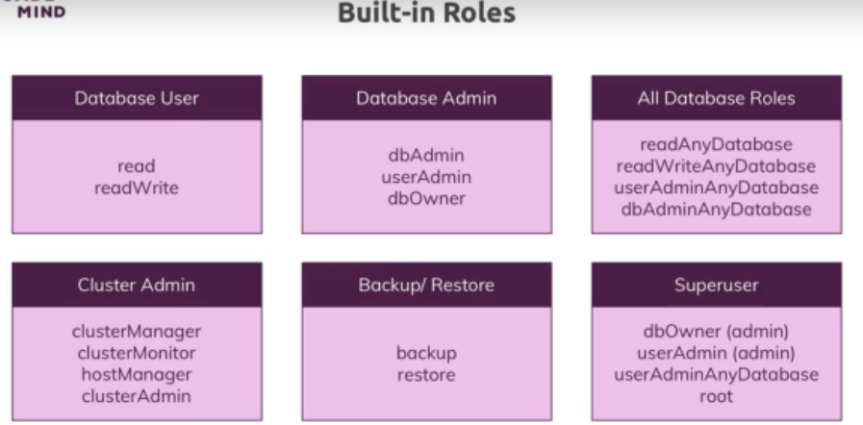

202. Assigning Roles to Users & Databases

203. Updating & Extending Roles to Other Databases

Assignment 8: Time to Practice - Security

204. Adding SSL Transport Encryption

You can do that in one command:

**# interactive**

**openssl req -x509 -newkey rsa:4096 -keyout key.pem -out cert.pem -sha256 -days 365**

**# non-interactive and 10 years expiration**

**openssl req -x509 -newkey rsa:4096 -keyout key.pem -out cert.pem -sha256 -days 3650 -nodes -subj "/C=XX/ST=StateName/L=CityName/O=CompanyName/OU=CompanySectionName/CN=CommonNameOrHostname"**

You can also add -nodes (short for *"no DES"*) if you don't want to protect your private key with a passphrase. Otherwise it will prompt you for *"at least a 4 character"* password.

The days parameter (365) you can replace with any number to affect the expiration date. It will then prompt you for things like *"Country Name"*, but you can just hit Enter and accept the defaults.

Add -subj '/CN=localhost' to suppress questions about the contents of the certificate (replace localhost with your desired domain).

Self-signed certificates are not validated with any third party unless you import them to the browsers previously. If you need more security, you should use a certificate signed by a [certificate authority](https://en.wikipedia.org/wiki/Certificate_authority) (CA).

205. Encryption at REST

206. Wrap Up

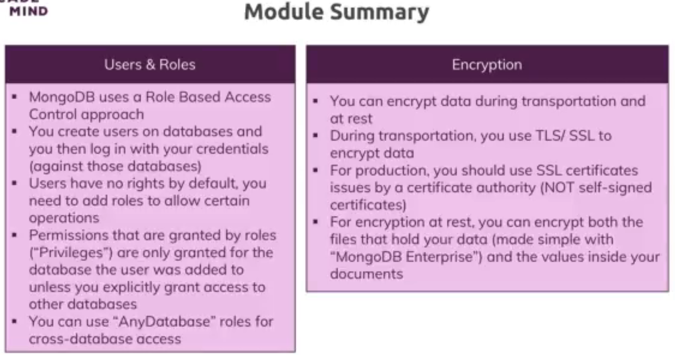

207. Useful Resources & Links

208. Module Introduction

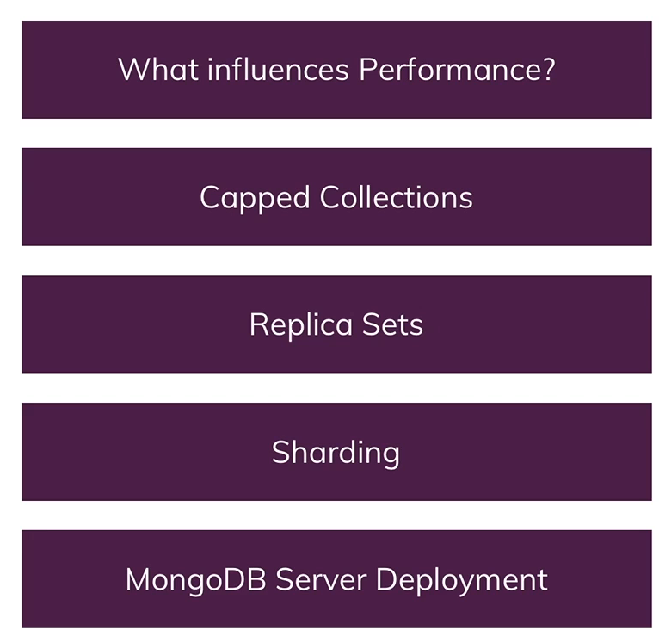

209. What Influences Performance?

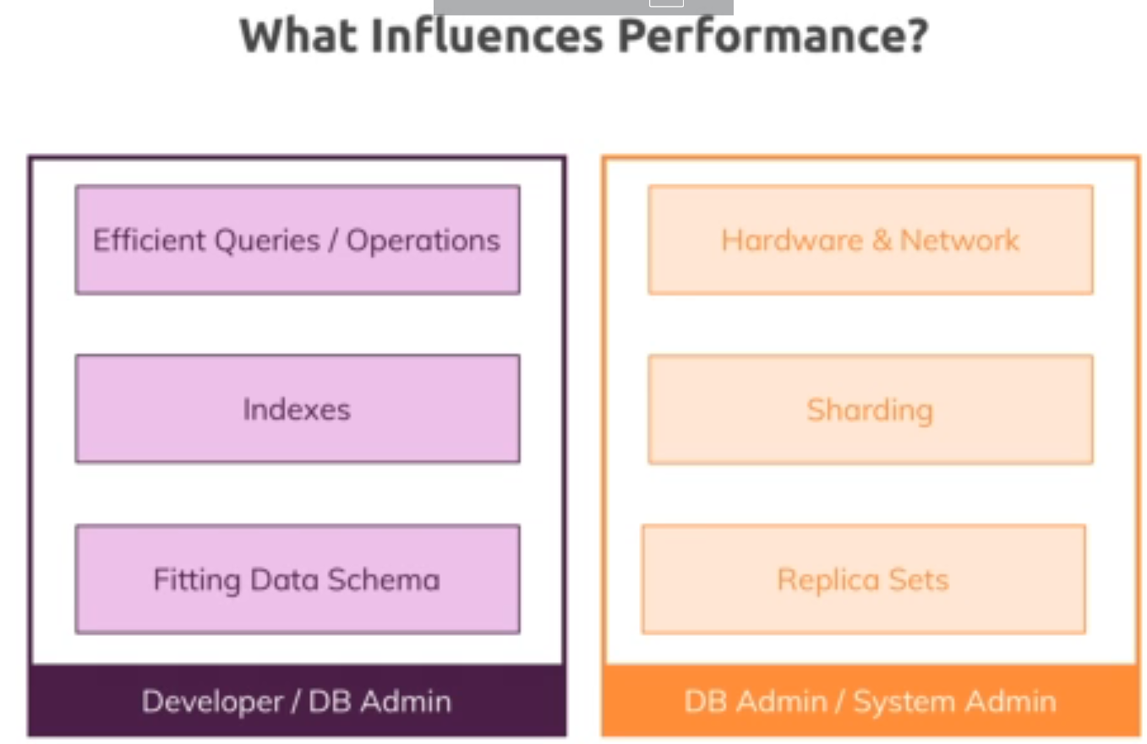

210. Understanding Capped Collections

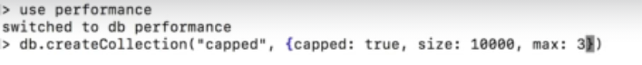

Order in which we insert, is the order in which we retrieve.

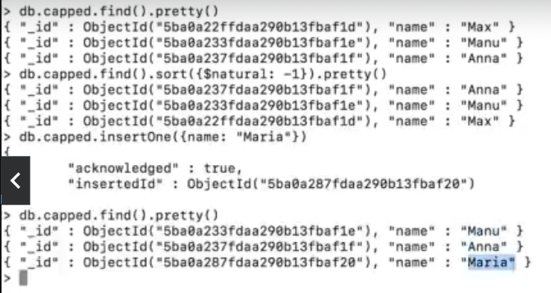

Capped collections in MongoDB are a special type of collection designed to maintain a fixed size and automatically overwrite the oldest documents when the collection reaches its maximum size. This makes them ideal for use cases where you need to maintain a rolling log or queue of a fixed amount of data.

**Key Features of Capped Collections:**

1. **Fixed Size**: You specify the maximum size (in bytes) and optionally the maximum number of documents when you create the collection. MongoDB enforces this limit, ensuring the collection does not exceed the specified size.
2. **Insertion Order**: Documents in capped collections are stored in the order they are inserted and cannot be updated in a way that changes their order or increases their size. This ensures that the order of documents remains consistent.
3. **Automatic Overwrite**: When the maximum size is reached, the oldest documents are automatically overwritten by new documents. This behavior makes capped collections useful for logging or caching where you only need the most recent data.
4. **High Performance**: Since the size of the collection is fixed, MongoDB doesn’t need to allocate additional space dynamically, leading to consistent performance. Reads are also fast due to the predictable document order.
5. **No Deletion**: You cannot delete individual documents from a capped collection. If you need to remove data, it will happen automatically as new documents are inserted.

**Use Cases:**

* **Logging**: Ideal for application logs, where only the most recent entries are important.
* **Caching**: Storing temporary data, such as session information, where you only care about the most recent items.
* **Message Queues**: Where a capped collection can serve as a simple, persistent FIFO (First In, First Out) queue.

**Example:**

To create a capped collection in MongoDB:

javascript

Copy code

db.createCollection("myCappedCollection", { capped: true, size: 1048576, max: 1000 })

* size: Specifies the maximum size in bytes.
* max: (Optional) Specifies the maximum number of documents the collection can hold.

When using capped collections, remember that they have limitations compared to regular collections, such as the inability to remove documents or perform certain types of updates. However, they offer a reliable and efficient way to manage a fixed-size dataset.

211. What are Replica Sets?

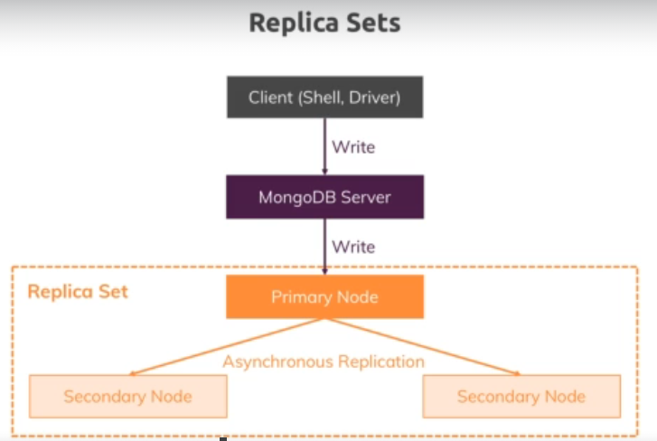

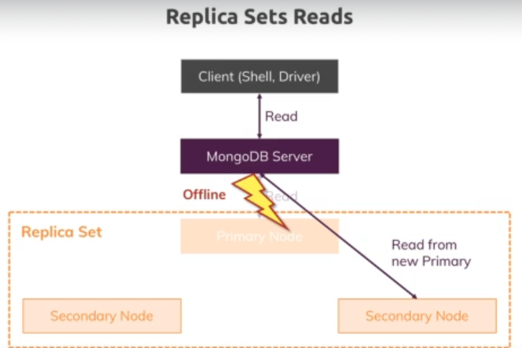

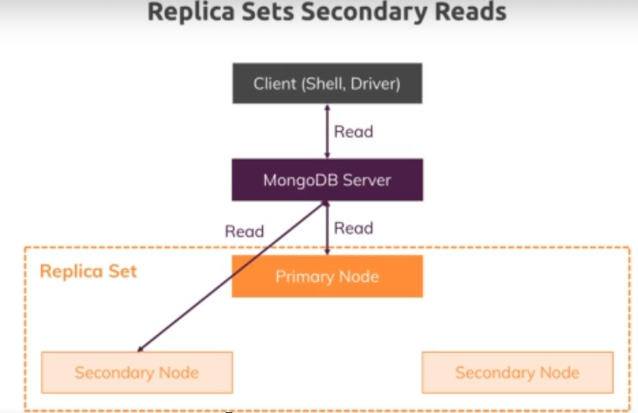

212. Understanding Sharding

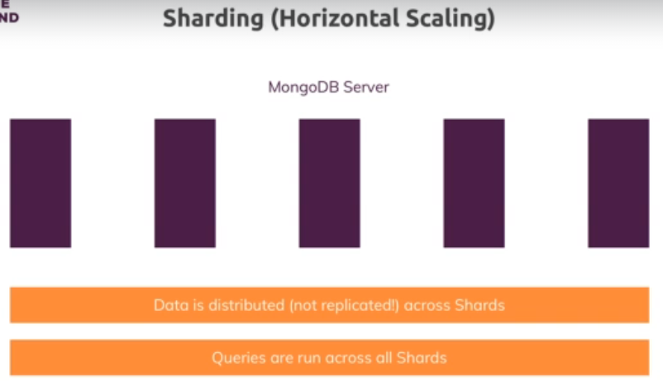

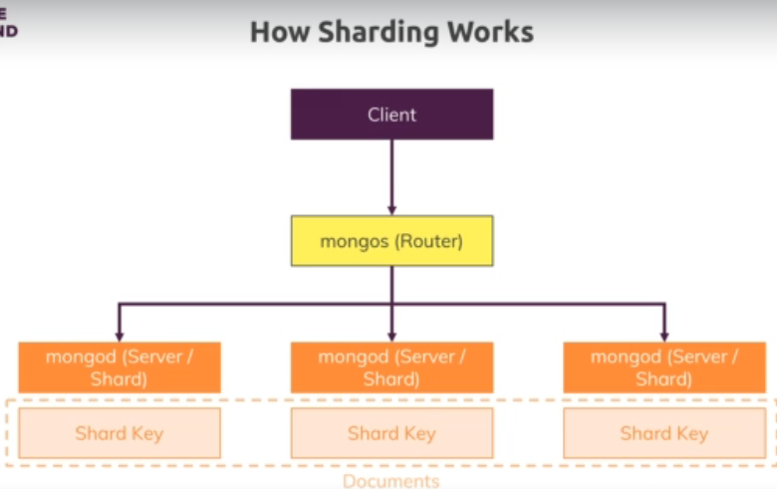

* 1. If shard key is not given

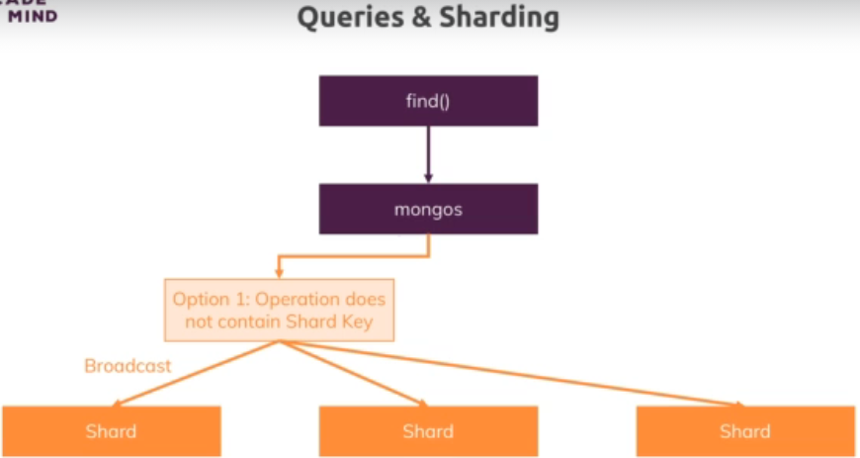

* 1. If shard key is give

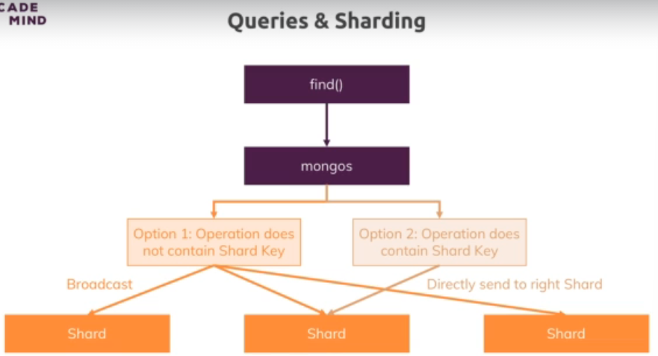

213. Deploying a MongoDB Server

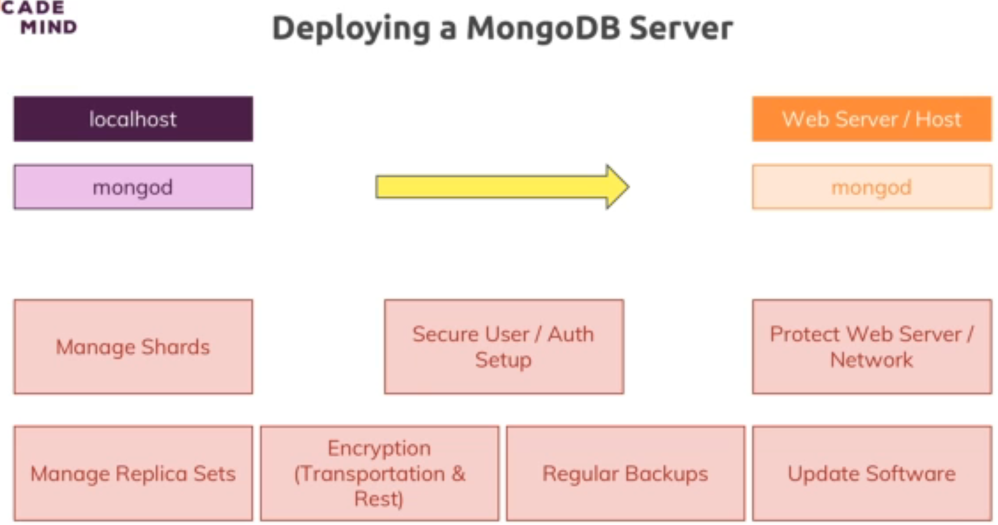

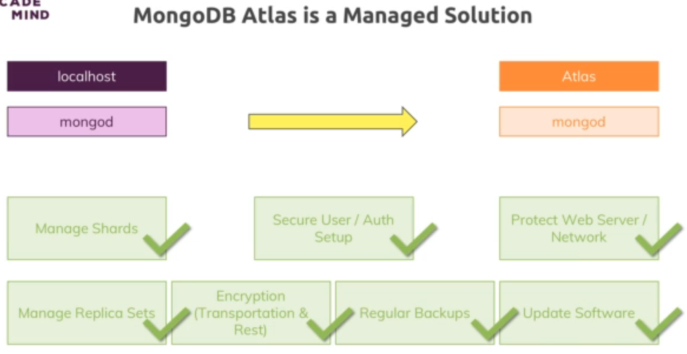

214. Using MongoDB Atlas

215. Backups & Setting Alerts in MongoDB Atlas

216. Connecting to our Cluster

217. Wrap Up

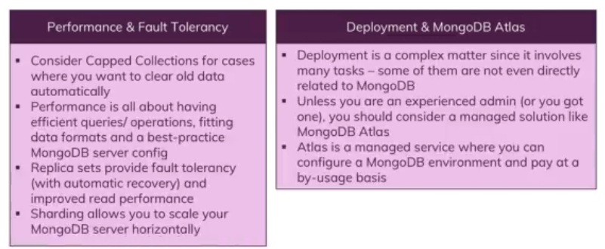

218. Useful Resources & Links

219. Module Introduction

220. What are Transactions?

221. A Typical Usecase

222. How Does a Transaction Work?

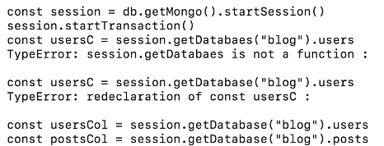

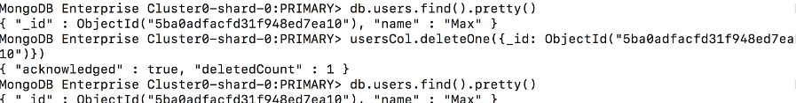

To commit:



223. Useful Resources & Links

224. Module Introduction

225. Splitting Work Between the Driver & the Shell

226. Preparing our Project

227. Installing Visual Studio Code

228. Installing the Node.js Driver

229. Connecting Node.js & the MongoDB Cluster

230. Storing Products in the Database

231. Storing the Price as 128bit Decimal

232. Fetching Data From the Database

233. Creating a More Realistic Setup

234. Getting a Single Product

235. Editing & Deleting Products

236. Implementing Pagination

237. Adding an Index

238. Signing Users Up

239. Adding an Index to Make the Email Unique

240. Adding User Sign In

241. Wrap Up

242. Useful Resources & Links

243. Module Introduction

MongoDB Stitch (now rebranded as **MongoDB Realm**) is a serverless platform that simplifies the development of modern applications by allowing developers to work directly with their MongoDB data using built-in services like authentication, triggers, and functions, without having to manage any backend infrastructure.

**Key Features of MongoDB Stitch/Realm**

1. **Serverless Functions**:
   * MongoDB Realm allows you to write and deploy JavaScript functions that can be triggered by various events (e.g., database changes) or called directly from your application.
   * These functions are serverless, meaning MongoDB handles the scaling and execution without you needing to manage any servers.
2. **Triggers**:
   * Triggers in MongoDB Realm allow you to execute functions in response to specific events, such as changes in the database (e.g., inserts, updates, deletes), scheduled times, or incoming HTTP requests.
   * This is particularly useful for tasks like sending notifications, processing data, or integrating with other services.
3. **Authentication and User Management**:
   * Realm provides built-in authentication services, supporting multiple authentication providers like email/password, OAuth (Google, Facebook, etc.), API keys, and custom JWT tokens.
   * It simplifies user management by handling authentication workflows, user registration, and session management.
4. **Data Access Rules**:
   * You can define granular data access rules in MongoDB Realm to control who can read or write specific parts of your data, ensuring that your application’s security needs are met.
5. **Sync**:
   * MongoDB Realm includes a real-time sync feature that allows you to automatically synchronize data between the backend MongoDB Atlas database and your client applications.
   * This is particularly useful for mobile applications that need to work offline and then sync changes when connectivity is restored.
6. **GraphQL API**:
   * MongoDB Realm automatically generates a GraphQL API based on your MongoDB schema, allowing you to query your database directly using GraphQL.
   * This is great for frontend developers who prefer working with GraphQL over traditional REST APIs.
7. **Third-Party Integrations**:
   * MongoDB Realm can integrate with third-party services like AWS, Twilio, and others via HTTP or using built-in service integrations.
   * This makes it easier to build applications that rely on multiple external services.

**Example Use Cases**

1. **Building a Mobile Application**:
   * You can use MongoDB Realm to manage user authentication, sync data between the mobile app and the cloud database, and execute server-side logic without needing to manage servers.
2. **Automating Workflows**:
   * With triggers, you can automate workflows, such as sending an email when a user registers or processing data when a new document is inserted into a collection.
3. **Creating a Real-Time Dashboard**:
   * You can build a real-time dashboard that displays data as it changes in your MongoDB database by using Realm’s sync capabilities and triggers.

**How to Get Started**

1. **Create a MongoDB Atlas Cluster**: MongoDB Realm is tightly integrated with MongoDB Atlas, so you start by setting up a MongoDB Atlas cluster.
2. **Set Up a Realm App**: In the MongoDB Atlas interface, you can create a Realm app, where you’ll configure authentication, rules, functions, triggers, and more.
3. **Use the Realm SDKs**: MongoDB provides SDKs for various platforms (JavaScript, Swift, Java, etc.) that allow you to interact with Realm services from your application.

244. Stitch & MongoDB Realm

245. What is Stitch?

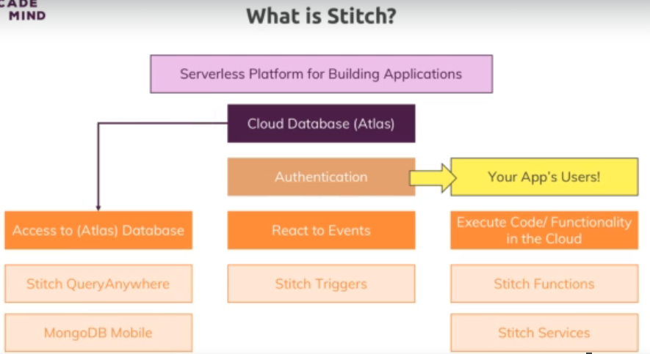

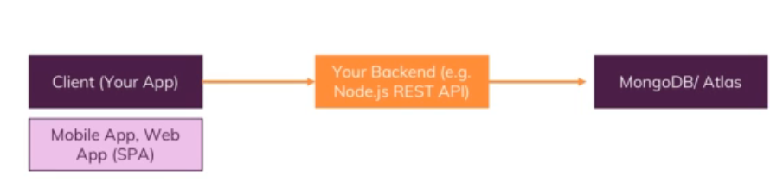

Is replaced by

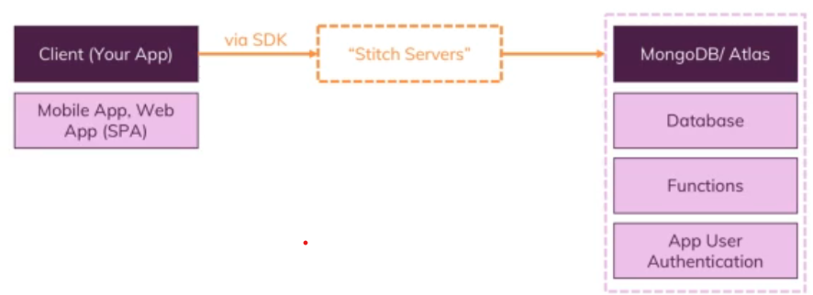

246. Preparations

247. Using Stitch

248. Adding Stitch to our App & Initializing It

249. Adding Authentication

250. Sending Data Access Rules

251. Fetching & Converting Data

252. Deleting Products

253. Finding a Single Product

254. Adding Products

255. Updating Products

256. Switching to User Email & Password Authentication

257. Adding User Sign Up & Confirmation

258. Adding User Login

259. Rules & Real Users

260. The Current State of Authentication

261. Functions & Triggers

262. Wrap Up

263. Useful Resources & Links

264. Course Roundup

265. Course Slides

266. Bonus: More Content!

Student feedback

No filter applied

4.6

Rating: 4.5931687 out of 5

Course Rating